Pressure-Flow Experiments, Packing, and Modeling for Scale-Up of a Mixed Mode Chromatography Column for Biopharmaceutical Manufacturing

Jessica Prentice†, Steven T. Evans†, David Robbins, Gisela Ferreira*
AstraZeneca
One MedImmune Way
Gaithersburg, MD 20878
USA

† Authors had equal contributions
*To whom correspondence should be addressed.
Email: FerreiraG@medimmune.com
Phone: (301) 398-2734
ABSTRACT
To obtain consistent chromatographic behavior, it is important to develop resin packing methods in accordance with the characteristics of each resin. Resins, particularly those with a significant level of compressibility, require proper knowledge of the packing methodology to ensure scalable performance. Pressure-flow modeling based on the Blake-Kozeny equation enabled a means to understand bed compressibility and to determine the minimum column diameter that can predict bed integrity during commercial manufacturing scale operation. This modeling was applied to the cellulose based mixed-mode chromatography resin MEP HyperCel (Pall). Studies suggested that scale-dependent wall effects become negligible for column diameters exceeding 20 cm. The pressure-flow modeling produced a minimum compression recommendation for the MEP HyperCel resin. Column packing with this compression, for column diameters up to 80 cm, was performed and pressure-flow data is presented. Further, the modeling results were verified for various MEP HyperCel column packing and operating conditions at the commercial manufacturing scale. This provides a methodology for the troubleshooting of unexpected high pressures at the commercial manufacturing scale.

INTRODUCTION
Column chromatography is used extensively in the biopharmaceutical industry to purify therapeutic proteins from complex feed streams. Development of commercial scale purification processes often employ column re-use (cycling) and/or column scale-up [2011 Gronberg] approaches. To obtain consistent chromatographic behavior over a column’s lifetime and during scale up, it is important to develop resin packing methods in accordance with the characteristics of each resin [2002 Cherrak, 2014 Siu].
Further, column operation can sometimes impact the column integrity over the course of a column lifetime if the column is deficiently packed in some manner (e.g., insufficient bed compression). Changing bed stability can lead to issues (e.g., abnormally high pressure drops across the bed, changing product pool volumes, or variable product quality) that can result in flow constraints and lost throughput. Chromatography development is typically performed using scale-down models, sometimes with pre-packed columns, which have been shown to be well packed for numerous stationary phases [2016 Scharl-Jungbauer]. With scale-up however, as the column diameter increases while maintaining constant bed height and superficial flow velocity, some effects at the small scale (e.g., forces exerted by the walls of the chromatography column hardware) can differ from those at larger scales. Chromatography operating conditions (e.g., bed heights, flow rates, or buffer solutions) identified at the small scale may not produce comparable product quality or process performance if the packing quality or wall effects change over the scaling-up. Upon scale-up at constant bed height, the resin compression will increase with increasing column diameter and concomitant decreases in the column aspect ratio (bed height divided by diameter). This is due to a phenomenon that as columns are scaled-up and as aspect ratios increase, the wall support to the packed bed decreases. Flow can induce increased compression of the resin, causing increased pressure drops across the packed bed and decreased bed stability. A further complication is that chromatography resins can exhibit varying degrees of compressibility. Resins with a significant level of compressibility may be particularly sensitive to the operating scale and packing conditions.
Several models have been developed to predict the pressure drop across packed beds at varying scales [2008 Keener]. Stickel and Fotopoulos [Stickel and Fotopoulos] developed an empirical model which correlates bed compressibility with column aspect ratio and superficial flow velocity. This model accurately predicts the critical velocity (u_{crit}) at which flow induced resin compression reaches its maximum. This compression is the critical compression (λ_{crit}), which is a resin specific parameter and is largely unaffected by column geometry. Columns packed at or above this compression behave as if they are incompressible, thus following the Blake-Kozeny equation [1922 Blake][1927 Kozeny][2002 BSL] for incompressible media. Pressure-flow modeling based on the Blake-Kozeny equation can be implemented to understand bed compressibility, wall effects, and determine the minimum diameter for a representative scale-down model that can accurately predict bed integrity and performance at commercial manufacturing scale.
MEP HyperCel (Pall) is an industrially relevant mixed-mode chromatography resin [2007 Thomas][2007 Abildskov][2008 Britsch][2009 Moingeon][2009 Carta][2014 Frey][2016 Scharl-Jungbauer]. This resin is highly compressible and the bead diameter changes with shifts in pH. While columns packed with this resin behaved consistently at small scale, we observed packed beds at the manufacturing scale to often be unstable due to formation of cracks and channeling. This resulted in lower step yields, higher pressure drops, and larger product pool volumes.
A case study is presented on the application of the Stickel-Fotopoulos approach to the development of a scalable packing method for the cellulose-based mixed-mode chromatography resin MEP HyperCel. Pressure-flow modeling based on the Blake-Kozeny equation was implemented. Optimal packing compression was determined based on model predictions. Predictable column performance data was confirmed for a range of column diameters.
Further, the modeling results were verified for various MEP HyperCel column packing and operating conditions at the commercial manufacturing scale. The influence of process solution viscosity, pH, resin slurry concentration, and accuracy of resin slurry delivery to the column on the recommended column packing predictions were illustrated. This is not only useful for the development of the best packing method for this resin, but is also useful to troubleshoot chromatographic behavior at the manufacturing scale. This is shown through a case study in which unexpected high-pressures were observed and the application of the modeling was used to identify the root cause.
The methodology outlined is applicable for other compressible resins.

EXPERIMENTAL

Materials
Sodium phosphate monobasic (monohydrate), sodium phosphate dibasic (heptahydrate), sodium citrate dihydrate, citric acid monohydrate, and sodium hydroxide were purchased from Avantor (Center Valley, PA, USA).
MEP HyperCel™ was purchased from Pall (Port Washington, NY, USA).

Apparatus
Laboratory-scale columns (Vantage-L, Millipore, Billerica, MA) had inner diameters of 1.15, 2.2, and 4.4 cm. Pilot-scale columns (BPG, GE Lifesciences, Pittsburgh, PA) had inner diameters of 20, 30, and 40 cm. Manufacturing scale columns (Euroflow Resolute DAP, Pall Corporation Port Washington, NY) had inner diameters of 80 and 140 cm. All columns used had adjustable heights.
ÄKTA Explorer 100 FPLC systems (GE Lifesciences, Pittsburgh, PA) were used with laboratory-scale columns. PK chromatography systems (Pall Corporation, Port Washington, NY) were used with pilot and manufacturing scale columns. Pressure drops across the columns were monitored using the ÄKTA/Resolution system and/or calibrated analog pressure gauges (Pellicon 0-60 psi gauge, Millipore, Billerica, MA).

Procedures

Packing pressure-flow curve generation
All equipment and materials were equilibrated to ambient temperature (15 – 25°C) prior to use. A pressure-flow curve without the column in-line, generated for each chromatography system, was used to subtract the equipment pressure drop from the total pressure drop to enable measurement of the pressure drop across the packed bed alone. All pressure-flow profiles have the equipment pressure drop subtracted. Before packing, the resin slurry concentration was determined by one of two methods: 1) allow a sample to gravity settle overnight in a graduated conical tube or 2) centrifuge a sample for 10 minutes at 1,600 G followed by a 30-minute static hold in graduated conical tube. To begin packing, a measured volume of slurry was poured into the column. The top adaptor was inserted into the slurry and flow started. To generate a packing pressure-flow curve, an initial flow rate generating less than 5 psig pressure drop was maintained until the bed consolidated. The flow rate was then increased incrementally, with pressure drop and bed height recorded at each increment. This was repeated until a non-linear response in pressure for an incremental change in pump speed was observed. Packing pressure-flow curves for MEP HyperCel were generated using a citrate buffer (100 mM sodium citrate pH 3.0) mobile phase.

Post-pack pressure-flow curve generation
Columns were packed according to internal packing procedures to the desired bed height specifications and tested to ensure passing packed bed quality. The flow rate was then increased incrementally and the pressure drop over the packed bed recorded at each flow rate increment. The final condition (flow rate and pressure drop) did not exceed vendor recommendations to avoid further bed compression. Post-packing pressure-flow curves for MEP HyperCel were generated in both citrate buffer (100 mM sodium citrate pH 3.0) and sodium hydroxide (0.1 N) mobile phases.

Modeling methodology
Modeling of pressure-flow behavior in columns was performed as described by Stickel and Fotopoulos [Stickel and Fotopoulos]. The methodology is summarized as follows:
1) Experimentally determine model parameters:
a) Packing pressure-flow curves were generated using multiple column aspect ratios as described in 2.3.1.
b) The critical velocity (u_{cri}) was determined from each packing pressure-flow curve as the point at which the pressure-flow relationship becomes non-linear.
c) The critical velocity times the initial bed height (u_{crit}L₀) was plotted against the aspect ratio (L₀/D). This yielded a linear relationship with the following correlation:
(Equation 1)
where the slope (m) and intercept (b) are empirical constants determined by linear regression. The empirical constant b is an indication of the resin’s compressibility, while the constant m is a measure of changing wall support.
d) Plot (u_{crit}L₀) against the inverse of the aspect ratio (D/L₀). This showed an asymptotic relationship as (D/L₀) increased (related to the intercept b from the plot of (u_{crit}L₀) against (L₀/D)). The asymptote indicated the point at which the wall effects became negligible.
e) The critical compression of the resin (λ_{crit}) is determined by taking the average critical compression from each packing pressure-flow curve determined in 2.3.1. Critical compression was determined as:
(Equation 2)
where L_{crit} is the bed height at u_{cri} determined in step (b).
f) Other model parameters (d_{p} = effective particle diameter, ε₀ = gravity settled bed porosity, µ = viscosity of mobile phase solution, and K₀ = empirical constant for the Blake-Kozeny equation) can be obtained from the resin manufacture and literature tabulated values.
2) Use the model to predict packing pressure-flow profiles (confirmation of model fit)
a) For a given column geometry (L₀/D), calculate the critical velocity (u_{crit}) using Equation 1 above.
b) Calculate bed compression using the following equation for a given linear flow velocity (u):
(Equation 3)
c) Calculate bed height for each compression:
$L=L_{0}-\left(λ*L_{0}\right)$ (Equation 4)
d) Calculate bed porosity for each compression:
(Equation 5)
e) Calculate the pressure drop (ΔP) as a function of velocity (u) using values from Steps 1f, 2c, and 2d using the Blake-Kozeny:
(Equation 6)
f) Repeat steps 2a through 2e for increasing linear flow velocities (u) until the critical velocity is reached (u = u_{crit}) to generate the pressure-flow curve. The model predicted pressure-flow curves will match the experimentally generated pressure-flow curves from step 1a, and as such will be non-linear.
g) Repeat 2a-f for other column geometries (L₀/D) to see how pressure-flow behavior changes with column geometry. The steps can also be repeated for other mobile phase conditions as needed.
3) Use the model to predict post-pack pressure-flow profiles and scale-up of the packed column
a) Pack columns to compression equal to or greater than the critical compression determined in step 1e.
b) Post-pack pressure flow curves will be linear with intercept at zero and slope ∆P_{crit}/u_{crit.}(where ∆P_{crit} was the pressure drop measured at u_{crit} from step 1 and/or 2f).

RESULTS AND DISCUSSION

Experimental determination of Stickel-Fotopoulos model parameters for MEP Hypercel
Prior to the application of the approach described in this paper, several issues were observed during the operation of MEP HyperCel chromatography columns at the large scale. These included elevated pressures, visible bed degradation (cracks), and raising concerns about potential impact on column lifetime and/or product quality. Further investigation showed that MEP Hypercel exhibited a pH dependent swelling behavior (the mean particle diameter ranged from 85 microns at pH ≥ 5.5 for equilibration, load, and post-load washes to 89 microns at pH 3.0 during the strip phase). At the compression factors used to pack these columns (≤ 0.248) this changing particle diameter resulted in an unstable packed bed, thus causing the manufacturing issues.
The impact of removing the low pH strip (to mitigate the pH dependent particle size effect) was studied by cycling the column with and without the strip (an acidic cleaning step). Absence of this cleaning step resulted in a significant reduction in column lifetime (from 100 to about 40 cycles). When the acidic pH cleaning step was restored, the performance of the column was restored, which confirmed the need for this step in the chromatography method.
As the chromatography method could not be altered to avoid steps that were known to induce bed swelling, the pressure-flow relationship of the column operation was modeled using the Stickel-Fotopoulos method to gain insight.
Packing pressure-flow curves for numerous packs at varying column aspect ratios were generated as described in Step 1 of Section 2.3.3 in the acidic strip buffer (where resin particle diameter is largest) (Figure 1). For each trace, as the linear velocity increases during packing the pressure drop increases gradually until a critical velocity (u_{crit}) is reached, at which point there is a dramatic increase in pressure preventing further increases in flow rate.
Figure 1: Experimental pressure-flow curves for the determination the critical velocity. Pressure drop (ΔP) is plotted against the linear velocity for various aspect ratios (L₀/D).

Figure 2a shows the various critical velocities (u_{crit}) determined from Figure 1 multiplied by the initial gravity settled bed height (L₀) and plotted against the initial gravity settled bed aspect ratio (L₀/D). A linear fit of the experimental data yields the parameters for the Stickel-Fotopoulos pressure-flow model from the slope (m) and the y-intercept (b) of the line (Equation 1). The empirical constant b is the value of (u_{crit} * L₀) for an infinite diameter column, which provides a numerical indication of the compressibility of a resin for a particular buffer composition: the lower the b coefficient the higher is the compressibility of the resin. The empirical constant m provides a numerical indication of the changing wall support as a function of scale: the larger the slope m the more sensitive the resin is to changing wall support. The m and b values (1,345 and 9,920, respectively) were greater than published values [Stickel and Fotopoulos] for Sepharose 4FF and Sepharose 6 FF resins (GE Healthcare), which ranged from 400-1,000 for m and 2,000-5,000 for the coefficient b. This indicates that the MEP Hypercel stationary phase is less compressible than the Sepharose resins, and that the changes in wall support more drastically impact the pressure-flow profile for MEP Hypercel than for the Sepharose resins.
Figure 2b, the normalized critical velocity plotted against the inverse aspect ratio, shows an asymptote at lower values of u_{crit}*L₀. This means that as the diameters of the columns become larger for a fixed bed height, the wall effects become negligible.
a)

b)
Figure 2: a) Critical velocity times initial bed height (u_{crit} * L₀) plotted against the aspect ratio (initial bed height divided by the diameter, L₀/D), b) Critical velocity times initial bed height (u_{crit} * L₀) plotted against the inverse of the aspect ratio (diameter divided by initial bed height, D / L₀).
As the linear velocity and pressure drop increase during packing, the resin bed height decreases (compression increases) until critical velocity (u_{crit}) is reached, at which point the bed compresses no further. This is the critical compression (λ_{crit}), and the resulting packed bed behaves as if incompressible, with scale-independent pressure-flow curves. Figure 3 shows the critical compressions for the columns from Figure 1. The maximum critical compression observed during the studies was 0.206.
Figure 3: Critical compressions, corresponding to the critical velocities determined in Figure 1, plotted against aspect ratio.
The experimentally determined Stickel-Fotopoulos model parameters are summarized in Table 1. The slope (m) and y-intercept (b) values were determined from Figure 2a using Equation 1. The maximum observed critical compression (λ_{crit}) was determined from Figure 3. Various small molecule dye tracer molecules were injected on to the column in an attempt to measure the gravity settled bed porosity. The MEP ligand irreversibly bound these tracers preventing the gravity settled be porosity measurement. A gravity settled bed porosity value of 0.41 was assumed [Stickel and Fotopoulos]. It was noted in the literature [2008 Keener] that for 9 commercially available resins the gravity settled bed porosity varied from 0.38 and 0.42.
Table 1: Stickel-Fotopoulos pressure-flow model parameters used for MEP Hypercel
Model Parameter | Value
m (cm² / hr) | 1,345
b (cm² / hr) | 9,920
λ_{crit} | 0.206
d_{p} (cm) | 0.00855ª
ε₀ | 0.41
µ (Pa s) | 0.001037^{b}
K₀ | 150^{c}
- Vendor information obtained from www.pall.com
- [2007 Lide]
- [Stickel and Fotopoulos]

Stickel-Fotopoulos model-predicted packing pressure-flow profiles for MEP Hypercel (confirmation of model fit)
The parameters (Table 1) were then used to model packing pressure flow curves as described in Step 2 of Section 2.3.3. The model-predicted curves for columns of various diameters ranging from 1.1 cm to 180 cm in diameter are shown in Figure 4.
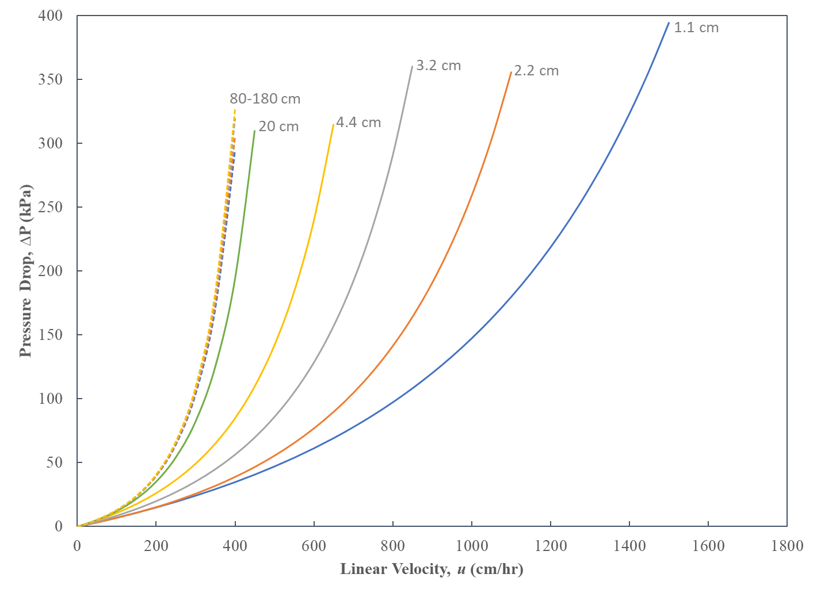
Figure 4: Pressure-flow modeling (Stickel-Fotopoulos) for gravity settled MEP beds in varying diameter columns.
The model predicted pressure-flow curves begin to overlap for columns having diameters greater than 20 cm, indicating that scale-dependent wall effects become negligible. This is consistent with the experimental data presented in Figure 2b for columns with diameters greater than 20 cm. These results confirm the fit of the Stickel-Fotopoulos model parameters in Table 1 for MEP Hypercel.

Post-pack pressure-flow profiles and scale-up of packed MEP Hypercel columns
For packed columns with stable beds, independent of column diameter scale, the column must be packed to compressions equal to or greater than the critical compression for the resin. Figure 3 showed the maximum critical compression value observed for MEP Hypercel in acidic strip buffer to be 0.206. To confirm that this is the appropriate compression for a stable bed, two MEP Hypercel columns were packed at compression values lower and higher than the critical compression value (λ = 0.130 and λ = 0.375, respectively) and the bed stability (as measured by the number of theoretical plates) was tested over several cycles. For the column packed at a compression of 0.130, the number of theoretical plates decreased with each cycle, suggesting instability of the packed bed and loss of chromatographic resolution (Figure 5). Conversely, the column packed at a compression of 0.375 maintained its number of theoretical plates and bed integrity. These results confirmed that packing the column at or above the critical compression value yields a stable packed bed, and a compression value of 0.375 was chosen as the target compression for all future MEP Hypercel columns to be packed in the manufacturing facility.

Figure 5: Packed bed integrity, as measured by theoretical plates per meter, for MEP Hypercel columns packed with compression levels of λ = 0.130 (◊) and λ = 0.375 (□).
Post-pack pressure-flow profiles were then generated for multiple columns with different diameters (1.1 – 80 cm, constant bed height of 19 ± 3 cm) packed with MEP Hypercel at the compression value of 0.375. Figure 5 shows the experimentally generated pressure-flow profiles, as well as the Stickel-Fotopoulos model-predicted pressure-flow profile. The plotted pressure-flow curves were all linear and showed good agreement with the model prediction.
Figure 6: Experimental post-pack pressure-flow curves for varying diameter columns packed with MEP HyperCel at a bed compression of 0.375.

Additional Considerations for Model Application
The application of the model in the manufacturing space can predict appropriate column packing for consistent bed integrity. The Blake-Kozeny equation (Equation 6) used in the modeling is dependent on several parameters whose variability should be considered in applying this approach to applications in which the packed columns is exposed to multiple different mobile phases: mobile phase viscosity, resin particle diameter, and resin porosity. As the chromatography column is cycled during processing, the packed bed is exposed to changing mobile phase properties (e.g. viscosity, pH). This is a challenge particularly for MEP Hypercel as the resin particle diameter shrinks and swells markedly with shifts in mobile phase pH. Additionally, inaccuracies in measurements of the percentage of resin slurry, packing flow rate, and volume of resin slurry delivered to the column can influence the actual compression achieved and thus resin porosity. The impacts of each of these parameters on the pressure flow model are explored below, including their consideration during troubleshooting in the manufacturing setting.

Viscosity and particle diameter
The work described in this paper thus far demonstrates the application of the model for MEP HyperCel in the acidic strip buffer. To test the impact of mobile phase properties on behavior of MEP HyperCel columns, pressure-flow curves were also generated in sodium hydroxide, which is the recommended packing solution for MEP Hypercel and in which the particle size is the smallest. Sodium hydroxide also serves as a surrogate for neutral pH equilibration and wash buffers because particle size was determined to have little variability above pH 5.5.
The acidic strip and sodium hydroxide solutions differ in both pH (influences bead size) and viscosity. MEP HyperCel resin particle diameter is 89 µm in the acidic strip buffer and 85 µm in sodium hydroxide solutions. Mobile phase viscosities are 1.037 cP for the acidic strip buffer and 1.021 cP and 1.232 cP, respectively, for 0.1 N and 1 N sodium hydroxide [2007 Lide]. Figure 7 shows the model predictions and the experimental data for the three solutions.

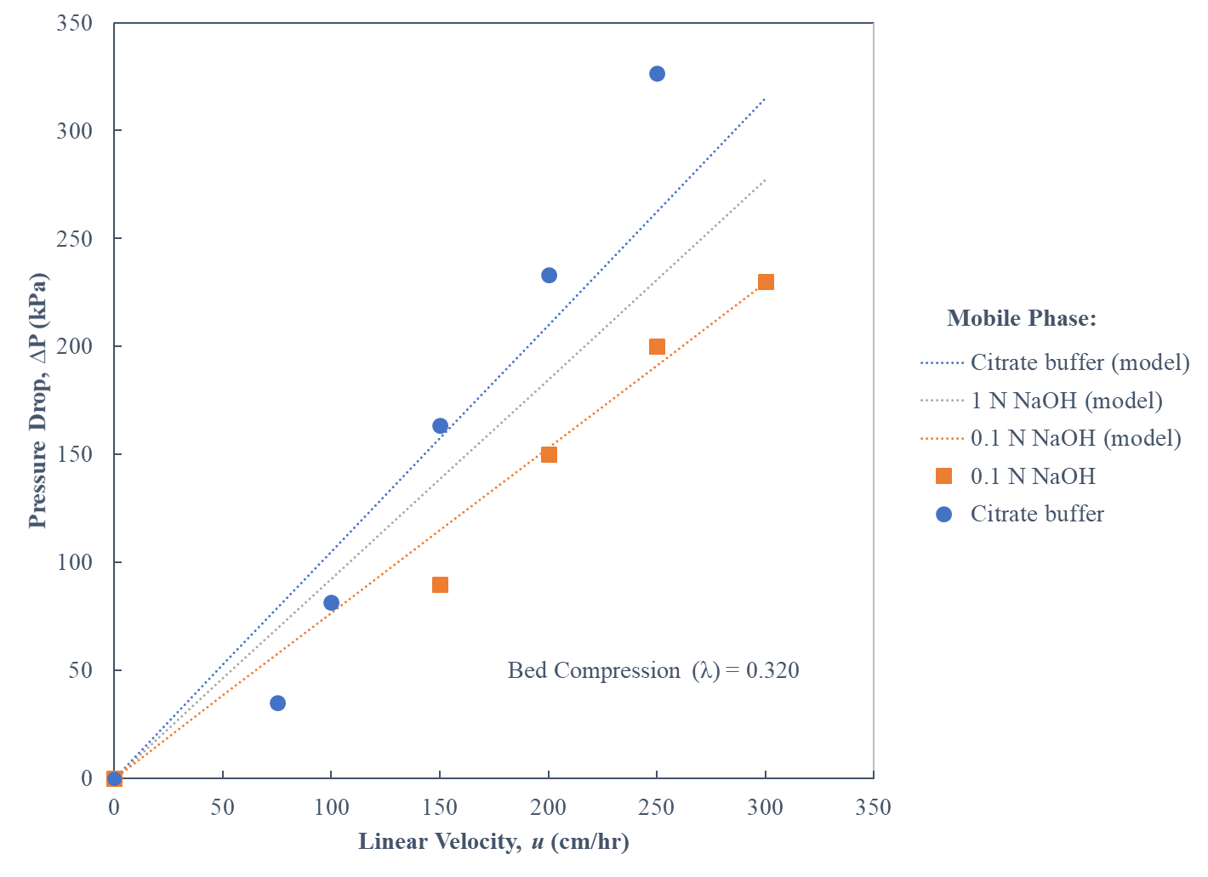
Figure 7: Impact of mobile phase on pressure-flow behavior. Model predictions are based on Blake-Kozeny equation incorporating known values for resin bead size and mobile phase viscosity.
The model predicts pressure drop can change as much as 40% between the solutions, in agreement with the experimental data. This exercise illustrates how modeling pressure drop for a single mobile phase, such as packing or equilibration conditions, may not accurately reflect the full range of column operation for the chromatography method. Multiple iterations may be necessary to gain full understanding of pressure-flow behavior and ensure a stable packed bed.

Porosity
After successful application and verification of model predictions in Section 3.3 for columns between 1 cm and 80 cm in diameter, it was assumed the model predictions would be scaleable for larger diameters in specifying column packing parameters for the manufacturing facility used to produce a monoclonal antibody product. The model predictions (target compression value of 0.375) were used to pack a 140 cm diameter column. During routine qualification of the column post-pack a pressure-flow profile was generated in the acidic strip buffer. The measured pressure-flow profile showed a much steeper slope than had been predicted (Figure 8).
Figure 8: Pressure-flow profile for the 140 cm diameter manufacturing-scale column as compared to the model prediction and pressure-flow curves for smaller scale columns.
An investigation ensued in the manufacturing facility that scrutinized factors such as resin slurry percentage, packing flow rate, volume of slurry delivered, and model fit assumptions. Parameters impacting the amount of slurry introduced into the column (volume totalizer and tank weight cell accuracy (Figure 9a) and slurry percentage (Figure 9b)) had a large impact on pressure drop, while packing flow rate had only a minor impact (results not shown). The root cause was found to be an inaccurate measurement of slurry percentage and too much resin being introduced into the column, resulting in an actual larger compression factor than intended (0.429 versus 0.375). Thus, the actual resin porosity was much lower than the porosity value used in the model.

Figure 9: Impact of (a) amount of slurry added to the column (flow totalizer and weight cell accuracy) and (b) slurry percentage on the predicted pressure drops.
When the predicted pressure-flow behavior was recalculated using the updated compression and porosity values, the model accurately predicted the behavior that was observed (Figure 10). This phenomenon was explained by Keener, et al. [2008 Kenner], who showed that the porosity term of the Blake-Kozeny equation (Equation 6) is dependent on bed compression according to the following expression shown in Equation 7:
(Equation 7)
where b is a fitted parameter from the packing pressure-flow curve experiments (different from b in Equation 1).
This exercise shows that no matter how good a mathematical model, a successful application needs to consider factors and variability external to the model. This investigation suggests an alternative application of the model to troubleshoot unexpected pressure-flow behavior.
Figure 10: The pressure-flow profile for the 140 cm diameter manufacturing-scale column (●) is accurately predicted (solid line) when the actual compression of 0.429 was used, as compared to the pressure-flow profiles and model prediction columns packed at the intended compression of 0.375 (other symbols, dashed line).

CONCLUSIONS
Modeling and experiments were used to gain a fundamental understanding of column performance for the mixed-mode resin MEP HyperCel. Potential failure mode concerns (e.g., compromised bed integrity) were addressed through the following measures 1) pressure-flow modeling, 2) implementation of adequate compression during column packing, and 3) column cycling studies.
Pressure-flow modeling was used to predict chromatographic bed compression, wall effects, and integrity at commercial manufacturing scales. Scale-dependent wall effects became negligible for columns of diameters greater than 20 cm. A bed compression greater than 0.21 yielded an incompressible resin bed resulting in scale-independent pressure-flow curves.
A case study of a larger column determined that variables external to the model can impact the predictive capability of the model for a packed bed. Mobile phase viscosity and pH as well as limitations in measuring equipment for the determination of the resin slurry concentration can exacerbate pressure drops at scale through variable compression factors.
Finally, the model can help troubleshoot high pressure observations and be used as part of a qualification of a packed bed to ensure process consistency.

ACKNOWLEGEMENTS
The authors would like to acknowledge Randal Lapcevich, Tolulope Ogunsola, Diemchi Vu, Brad Matanin, John Higgins of AstraZeneca.

Funding
This research did not receive any specific grant from funding agencies in the public, commercial, or not-for-profit sectors.

REFERENCES
[2011 Gronberg] A. Grönberg, M.Eriksson, M. Ersoy, H.J. Johansson. A tool for increasing the lifetime of chromatography resins. mAbs 3:2, 192-202 (2011).
[2002 Cherrak] D.E. Cherrak, M. Al-Bokari, E.C. Drumm, G. Guiochon. Behavior of packing materials in axially compressed chromatographic columns. Journal of Chromatography A, 943 (2002) 15–31.
[2014 Siu] S.C. Siu, C. Chia, Y. Mok, P. Pattnaik. Packing of large-scale chromatography columns with irregularly shaped glass based resins using a stop-flow method. Biotechnology Progress. 30 (2014) 1319–1325.
[2016 Scharl-Jungbauer] T. Scharl, C. Jungreuthmayer, A. Dürauer, S. Schweiger, T. Schröder, A. Jungbauer. Trend analysis of performance parameters of pre-packed columns for protein chromatography over a time span of ten years. Journal of Chromatography A, 1465 (2016) 63-70.
[2008 Keener] R.N. Keener III, E.J. Fernandez, J.E. Maneval, R.A. Hart. Advancement in the modeling of pressure-flow for the guidance of development and scale-up of commercial-scale biopharmaceutical chromatography. Journal of Chromatography A, 1190 (2008) 127–140.
[Stickel and Fotopoulos] J. Stickel, A. Fotopoulos. Pressure-flow relationships for packed beds of compressible chromatography media at laboratory and production scale. Biotechnol. Prog. 17, 744-751 (2001).
[1922 Blake] F.C. Blake. Trans. Amer. Inst. Chem. Engrs. 14, 415-421 (1922).
[1927 Kozeny] J. Kozeny. Sitzungsber. Akad. Wiss. Wien. Abt. IIa, 136, 271-306 (1927).
[2002 BLS] R.B. Bird, W.E. Stewart, E.N. Lightfoot, Transport Phenomena, Second Edition, Wiley, New York, p. 190.
[2007 Thomas] H. Bak, O.R.T. Thomas. Evaluation of commercial chromatographic adsorbents for the direct capture of polyclonal rabbit antibodies from clarified antiserum. Journal of Chromatography B, 848 (20070 116-130.
[2007 Abildskov] H. Bak, O.R.T. Thomas, J. Abildskov. Lumped parameter model for prediction of initial breakthrough profiles for the chromatographic capture of antibodies from a complex feedstock. Journal of Chromatography B, 848 (2007) 131-141.
[2008 Britsch] V.B. Brochier, A. Schapman, P. Santambien, L. Britsch. Fast purification process optimization using mixed-mode chromatography sorbents in pre-packed mini-columns. Journal of Chromatography A, 1177 (2008) 226-233.
[2009 Moingeon] V.B. Brochier, H. Chabre, A. Lautrette, V. Ravault, M. Couret, A. Didierlaurent, P. Moingeon. High throughput screening of mixed-mode sorbents and optimization using pre-packed lab-scale columns for the purification of recombinant allergen rBet v 1a. Journal of Chromatography B, 877 (2009) 2420-2427.
[2014 Frey] H. Guo, X. Li, D.D. Frey. Development of chromatofocusing techniques employing mixed-mode column packing for protein separations. Journal of Chromatography A, 1323 (2014) 57-65.
[2009 Carta] E.X. Perez-Almodovar, G. Carta. IgG adsorption on a new protein A adsorbent based on macroporous hydrophilic polymers II. Pressure–flow curves and optimization for capture. Journal of Chromatography A, 1216 (2009) 8348–8354.
[2007 Lide] Lide D R 2007 Concentrative properties of aqueous solutions CRC Handbook of Chemistry and Physics 88th edn (Boca Raton, FL: CRC Press) (Internet Version 2008) pp. 2620-2046.

